Financial Statement Dashboard
Project Overview
This project demonstrates the creation of an interactive financial dashboard in Power BI to visualize a company’s key financial metrics over a five-year period.
Tools Used
- Excel
- Power BI Desktop
- DAX (Data Analysis Expressions)
Dataset
A fictional company financial dataset covering:
- Revenue
- COGS
- Operating Expenses
- Net Profit
- Total Assets
- Liabilities
- Equity

Key KPIs
- Net Profit Margin
- Debt-to-Equity Ratio
- Return on Assets (ROA)
Insights
- Revenue grew steadily at ~8% CAGR (2020–2024).
- Net Profit Margin improved from 14% to 16%.
- Debt-to-Equity ratio remained stable at ~0.7.
- ROA improved, showing better asset utilization.
- COGS rose proportionately but operating expenses grew slower.
Business Impact
This dashboard provides management with quick insights into financial health, supporting better strategic decisions.
Dashboard Screenshot
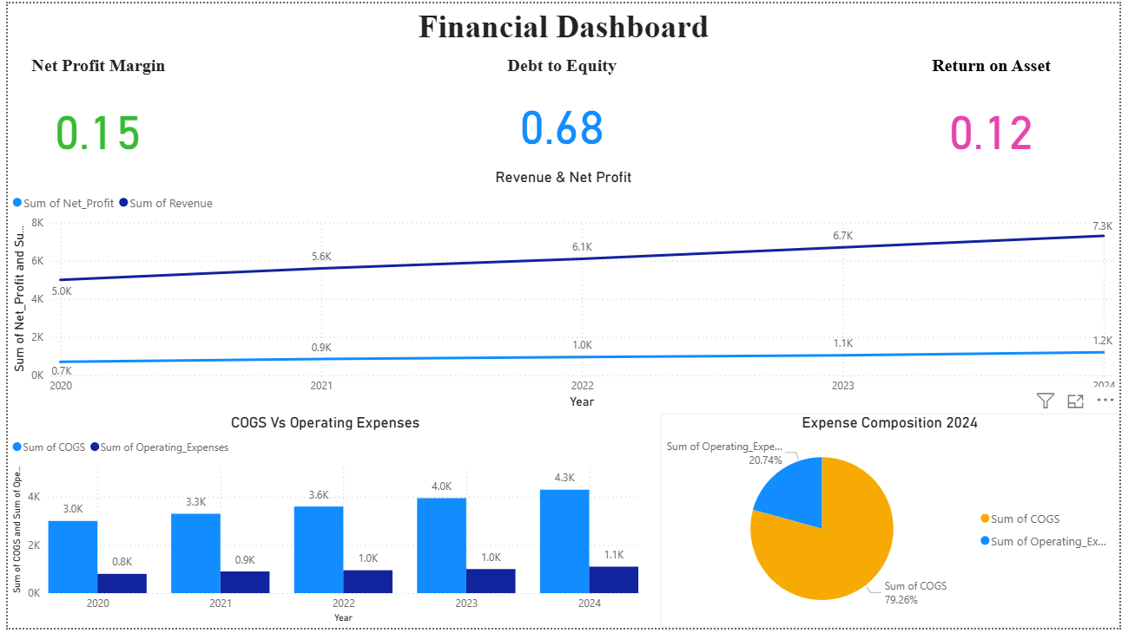
Author
Sakshi Wanjari

